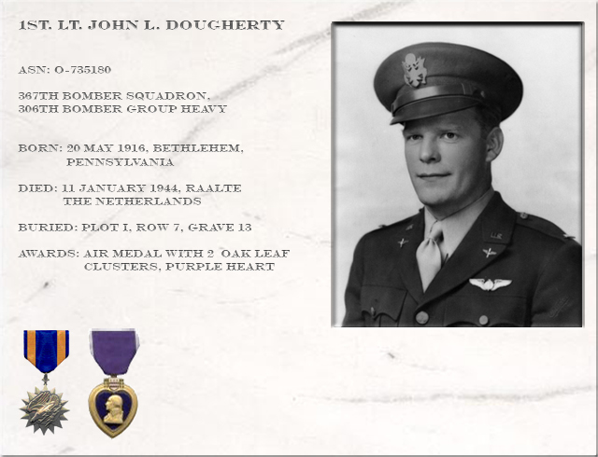
John Leo Dougherty was born on May 20, 1916 in Bethlehem, Pennsylvania. His parents, Rose Kelly and Harry Dougherty were the children of Irish immigrants who had come to Pennsylvania to work in the Bethlehem Steel Mill.
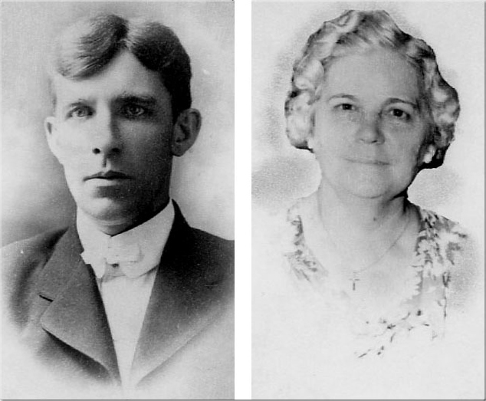
Harry and Rose Dougherty
Jack (as he was called by friends and family) was the youngest of their seven children. His Father was killed in an accident at the Bethlehem Steel Mill
in November, 1921 when Jack was five years old. His mother Rose took in boarders in order to support her family.
After graduating from Bethlehem Catholic High School in 1934, Jack enrolled in St. John’s Home Missionary Seminary in Little Rock, Arkansas in order to become a Roman Catholic priest. Illness forced him to return home to Bethlehem after 3 semesters in the seminary.
In 1937 he enrolled in the Catholic University of America in an area of northeast Washington, DC known as Brookland.
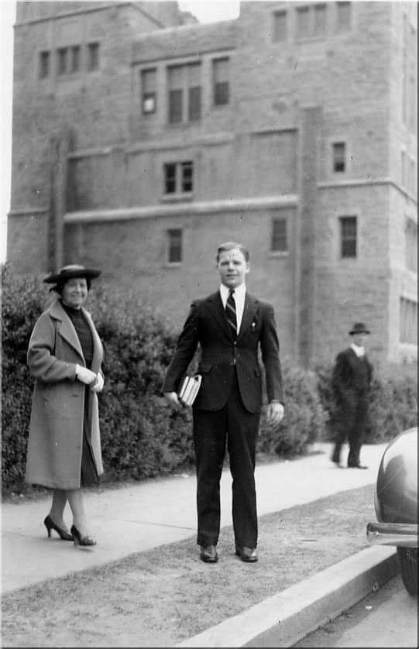 | 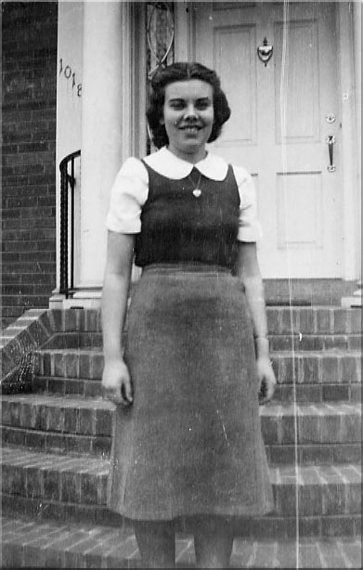
Jack Dougherty with his Aunt Julia Kelly at Catholic University, Washington, D.C. | Nora Byrnes
Several blocks from school, at 1014 Monroe Street, lived a large Irish family headed by a widow, Josephine Byrnes. Her home was a favorite boarding house for the Catholic University students since one of the dormitories on campus had closed for renovation. Like Rose Dougherty, Josephine took in boarders to support her seven children. It was to this home that Jack Dougherty came one day searching for a room to rent. Besides a place to live while at school, the Byrnes house provided Jack with family companionship in an Irish community very similar to his own in Pennsylvania. Best of all, while Josephine had six sons, she had one very pretty daughter named Nora… life was good!
During his time at Catholic University, in addition to the basic academic requirements, Jack studied German and philosophy, played a good game of golf and sang in the glee club. He graduated from Catholic University on June 26, 1941 with a Bachelor of Arts degree with a specialization in education.
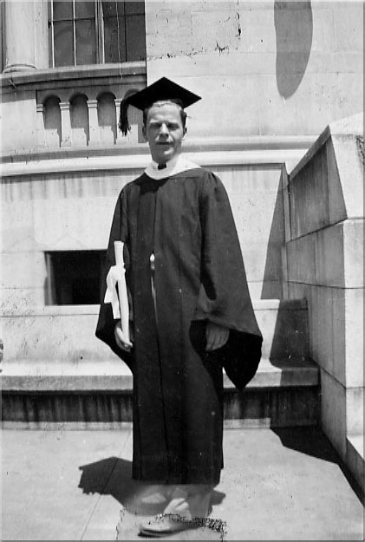
Jack at his Catholic University Graduation
Nora, in the meantime, had graduated from St. Anthony High School and was attending Medical Technology classes at Georgetown University while working in the office of her Monroe Street neighbor, Dr. John A. Simpson.
In August 7, 1941 Jack was inducted into the Army in Richmond, Virginia. The majority of his records were destroyed in the fire in a St. Louis, Missouri U.S. Government warehouse. Those that remain show him as a PFC in the Army Quarter Master Corps, Headquarters, 1307 Services Unit, Camp Lee, Virginia for a portion of his early training.
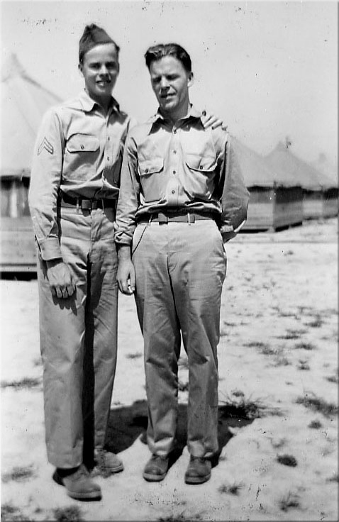
Jack (right) with his friend Don Hardesty (left) at Camp Lee, Virginia in August 1941
He was transferred to Aviation Cadet training on January 2, 1942 with the Army Air Force to Maxwell Field near Montgomery, Alabama. At the time this base was home to six different schools that trained U.S. military aviators and their support teams for wartime service.
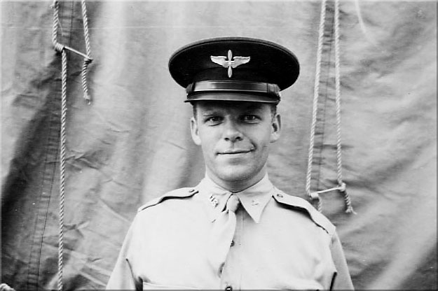
Jack as an Aviation Cadet
Sometime between September 1937 and June 1941, Jack and Nora fell in love.
They were married by Jack’s brother James at Immaculate Conception Church in Washington, D.C. on May 2, 1942. At the time, Jack was on leave and had attained the rank of Sergeant in the US Army.
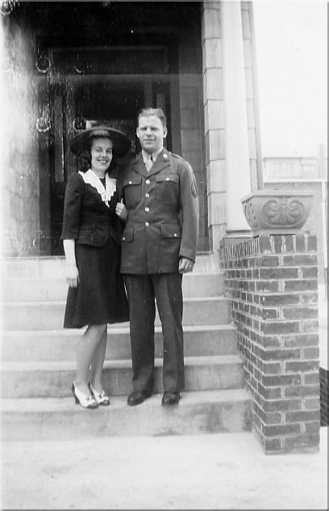 | 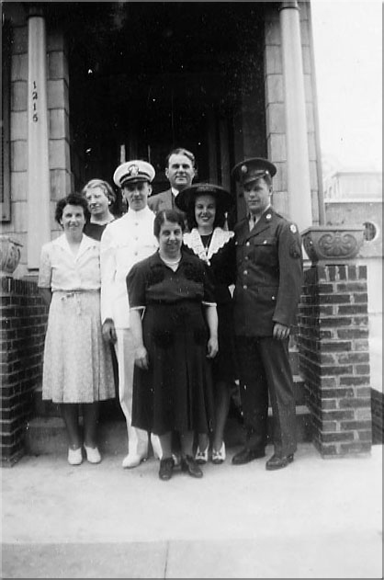
Jack and Nora on their wedding day | Nora’s Mother Josephine Byrnes in front center, Mrs. Agnes Simpson on left, Dr. John Simpson top center

Schooled as a bombardier at Williams Field in Chandler, Arizona from November 2, 1942 until December 31, 1942, Jack graduated with the WC 43-1 Class on January 2, 1943.
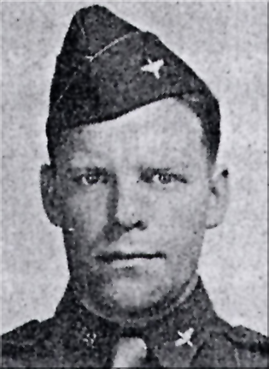
Jack - Bombardier graduation photo
Lt. John L. Dougherty page 2
By January 7, 1943 he had been ordered to Hondo, Texas and enrolled in Navigator School from which he graduated on May 13, 1943.
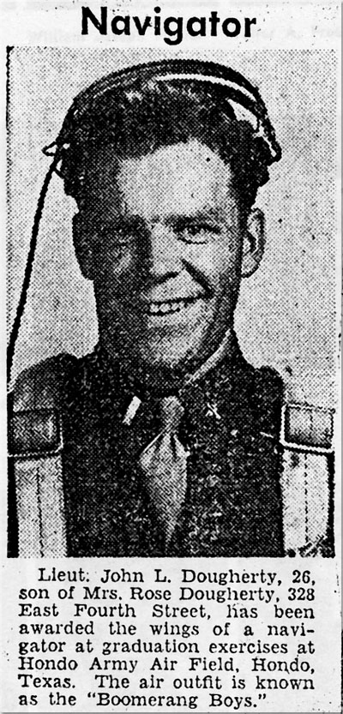
Jack in newspaper clipping after Navigator school graduation
On April 10, 1943 in Washington, D.C. Nora gave birth to a baby girl. Dr. Simpson and his wife Agnes attended the birth. Jack had been notified by telegram that the baby girl had arrived. He wrote to Nora that day and told her that the only name for the baby that would suit him would be “Nora”. He hoped the baby would be as sweet as her Mother! Released from training after his May 13th graduation, Jack, Nora and Little Nora, spent time with their families in Washington, D.C. and Bethlehem, Pennsylvania.
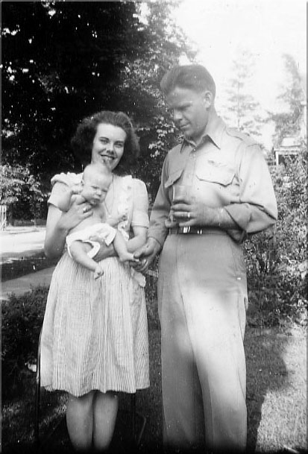 | 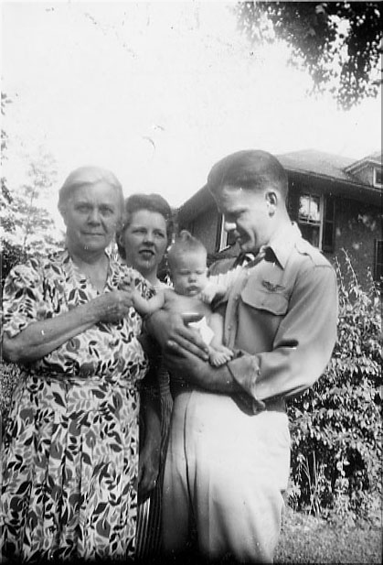
Jack, Nora and Little Nora | Jack, Mother Rose, Sister Mary and Little Nora
The next assignment saw him transferred June 3, 1943 to Army Air Base, Dalhart, Texas. The newly formed crew was given a furlough from July 8th until July 15th and Jack went home to be with Nora during this time. Following the furlough, the crew was to report to Grand Island, Nebraska. They left Grand Island on August 15th and took a train east. Arriving in the Norfolk/Hampton Roads area, they left on the USS Argentina on August 20, 1943 and arrived at Thurleigh, England around September 7th.
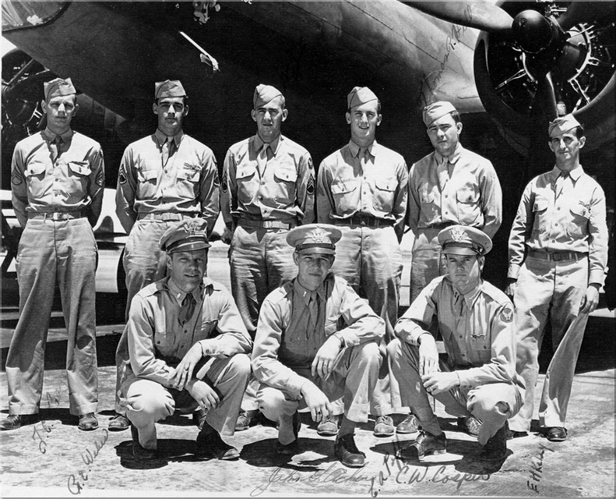
Jack with his original crew members (back row, left to right) Tom Boyd, Bob Weber, George Roberts, Cecil Poff, Thomas Hill, E.H. Kelly
(front row, left to right) Jack Dougherty, John Acker, Clyde Cosper
Assigned to the 306th Bomb Group, 367th Bomb Squadron, local flying, navigation exercises and the study of terrain, weather and combat operations followed. Considered the “old man” at 27, Jack spent whatever spare time he had reading, writing letters, studying and working on calculations. The pictures sent from home were covered with navigational coordinates he had penciled on the photo backs! He enjoyed humorous, classic American poetry that told a story
as well as pithy, witty statements. His books show an active and interactive reader. He underlined, wrote notes in the margins, drew sketches around verses and tabbed pages that must have been favorites or were meaningful to him. A few of the books he chose to keep with him were: Best Loved Poems of the American People, Tony’s Scrapbook which was “an anthology of noble thoughts, snatches of homely humor… and tributes to …diligence, nature, and perseverance”, his brother James’ dictionary, The Golden Treasury: Selected from the Best Songs and Lyrical Poems in the English Language, and a Catholic missal.
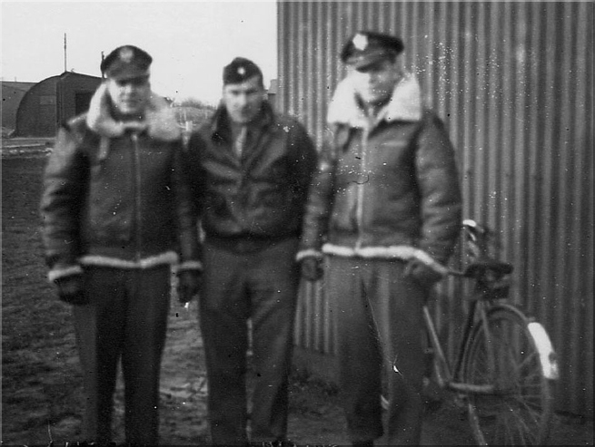
Jack (far right), 1st Lt Joseph Sparks (left), unknown (center) at Thurleigh, England
Flight records show that he flew as a navigator beginning October 2, 1943 with the first combat mission on October 8 to Bremen. A crewmate remembers Jack talking about an impending mission in a light bantering manner to relieve the growing tension within the crew. He flew in the second raid on Schweinfurt October 14, 1943. A crewmate later wrote “Bombers, fighters and parachutes filled the sky. We were hit, knocking out one engine and the oxygen supply to the back of the plane. We had to leave our stations and go to the front of the plane and get on another supply of oxygen. Since we had lost some of our fire power and one engine, we got under the rest of the formation for protection, since the German fighters would go after any bomber that had been damaged. Over Schweinfurt, we were under attack by 40 to 50 fighters. This mission so reduced the 8th Air Force that no further missions to the heart of Germany were possible until early 1944. This engagement is generally acknowledged as having been the most savagely fought air battle in history.”
Another crewmate said the following about that mission: “This was of course the worst mission and ours was the only plane in the 367th to even reach the target. We had three shot down (10 in the group). This was the last mission we flew in this plane as it was really torn up by fighters. Just let me say that since we returned to base on our own with most of our radio equipment out of commission John Dougherty did a masterful job. The weather on return was horrible and we were fortunate to find a small break in the clouds to let down.”
On January 11, 1944, during a mission to Halberstadt, Jack’s 19th combat mission, his plane was shot down over Raalte, Holland near the Bessenbender farm around 1:30 PM local time. The entire crew was killed. This mission was led by Colonel George Robinson who said years later that this was the worst mission he had ever flown and the fliers were lucky to be able to get back to base. The group had five planes shot down and 43 of the 50 airmen involved were killed. Jack and his crew were declared missing in action until information was received in March 1944 from the Red Cross indicating that the crew had all been killed
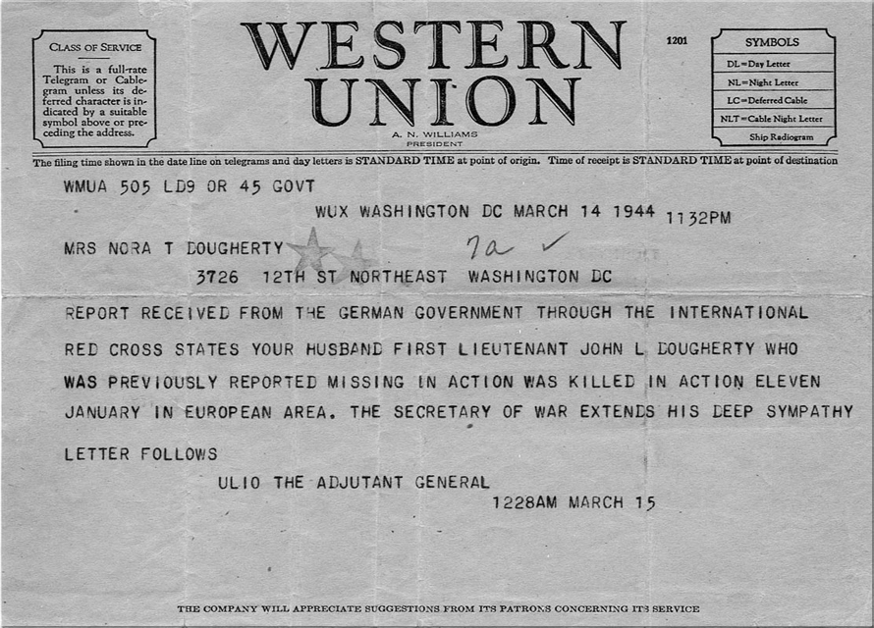
Telegram sent to Nora in March 1944
John Dougherty and his crewmates were buried by the people of Raalte and Almelo, Netherlands in the community cemetery in Raalte on January 14, 1944 At the time of his death Jack was survived by his wife Nora, nine month old daughter Nora, his mother Rose, brothers James and Joe and sisters Margaret and Mary as well as Nora’s six brothers and her mother Josephine.
He was moved by the United States Government to the Netherlands American Cemetery outside of Maastricht, Netherlands on December 19, 1945 and buried in Plot BBB, Row 4, and Grave 82. Following the repatriation of many of the men buried in the Netherlands, the cemetery was reformed and John Leo Dougherty remains there at his wife’s wish in Plot I, Row 7, and Grave 13.
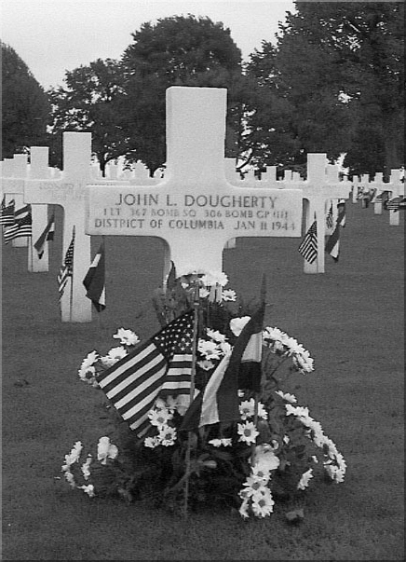
Jack’s grave in Netherlands American Cemetery

~~~~
Summarizing the life of John Leo Dougherty is a task limited by available knowledge and dimming memories. One can relate dates, times, locations, and circumstances. His essence is and will remain hidden, but the memories of his family, friends, and comrades provide glimpses of him:
He was beloved in his family, very much in love with Nora and delighted to be a father.
He was deeply religious, diligent in his studies, professional and courageous in his work.
He had a strong sense of the need for equality among men, enjoyed quiet and subtle humor and wanted to become a teacher.
The lives he touched were irrevocably changed not only by his death, but by his life.
Memories retain glimpses of the man; hearts retain the love of the man.
Loved and cherished during his time with us.
In God’s loving care forever.
A special word of gratitude for sharing information is going out to :
Mrs. Nora Dougherty Costello , daughter of 1st Lt. John L. Dougherty, and her husband Mr. J. William Costello, M.D.
and the following men of the 306th BG, 367th BS and their families:
Mr. Thomas Boyd, Engineer, Original Crewmember
Mr. Cecil Poff, Aerial Gunner, Original Crewmember
Mr. George G. Roberts, Combat Radio Operator, Original Crewmember
Mr. William F. Houlihan, Medical NCO
Mr. John Schupp, Squadron Clerk / Barracks Orderly

