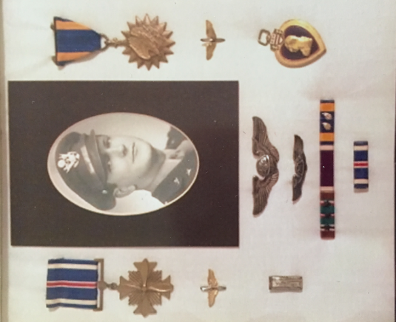

My Last Mission
A Story about my Great Grandfather
Gerald “Jake” Weiler
1st Lieutenant, Navigator (Serial # 0-717-543)
306th Bombardment Group (Thurleigh, England 7/21/44 – 9/23/44)
367th Bombardment Squadron “Clay Pigeons”

By Colin Scruggs, Age 10
Gurnee, Illinois
USA
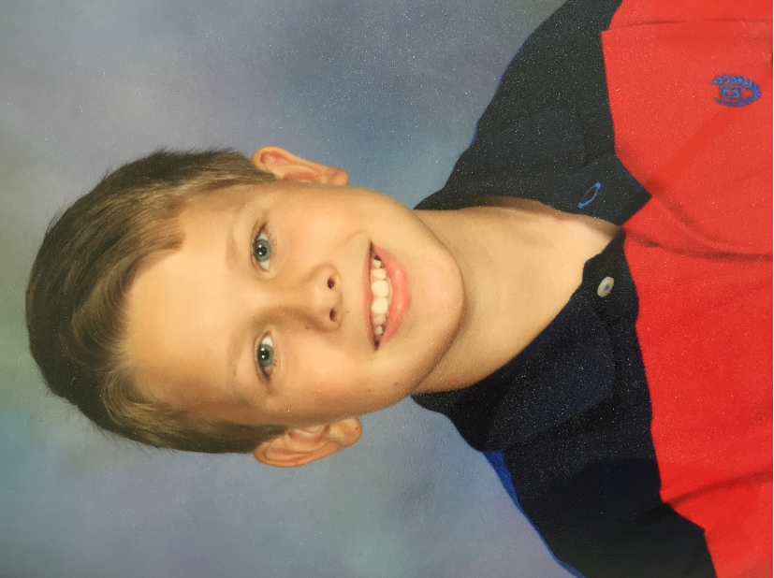
A.L.A. – December 1st, 2013

It was very early in the morning during World War II on September 12th, 1944 in England. I was with over a hundred men gathered around the large map in the briefing room showing our target near Berlin, Germany. Our mission that day was to bomb an oil refinery because all fuel comes from oil. We also had to attract enemy fighter planes to our prodigious formations of B-17 bombers. If all went well, our escort P-51 fighter planes would shoot down the enemy FW-190's and ME-109's that would try to attack.

It was still dark outside as we walked towards our exquisite Boeing B-17 bomber that was waiting quietly on the tarmac. For the moment, our airbase was serene as the rest of my ten man crew was preparing the aircraft for flight. Many others were doing the same with their bombers too.

The four engines of our heavy bomber started with a great clamor and we taxied to the runway for take-off with several other bombers in our group. We were on our way to Berlin, Germany and it as my job as navigator to get us there. My thoughts about this mission were profound as we climbed into the sky.

After two hours of flying we were over enemy territory up at twenty thousand feet with the rest of our fleet of B-17s in formation. Suddenly there was an acute bang outside the plane and I could see flak was exploding all around the high group while the low group tried to descend. Flak was what we called the explosive shells that the Germans fired at us from the ground. It explodes in large black puffs and put grotesque holes in our planes.

After all the confusion from the flak attack, twenty-five enemy fighter planes began their attack on us. We did our best to defend ourselves with only our machine guns. The escort P-51's that were supposed to protect us were elsewhere during the attack. The battle only lasted five to six minutes, but about seven of our bombers were downed by the German FW-190's and a few others were lost to the flak. I didn’t know it at the time, but that was only the beginning of the excitement of this mission. Many men parachuted from their planes as they caught fire. About half of the men in the 306thBombardment group who parachuted were captured and later liberated. The other half weren’t as lucky and died from the fall. A few escaped to neutral or allied countries. The remaining bombers gathered into formation again and I still had to navigate us to our target.

The large oil refinery was manifest even from twenty thousand feet and we dropped our bombs on the target. We were then on our way back to England with about three hours of flying to go. But our plane was tremulous from the sputtering engines which had been shot up during the battle. The bomber was languishing as we slowed to a crawl. We were now a sitting duck with only one working engine but some P-51's finally arrived to escort us back home until we were out of range of the enemy fighters. After that we were on our own.

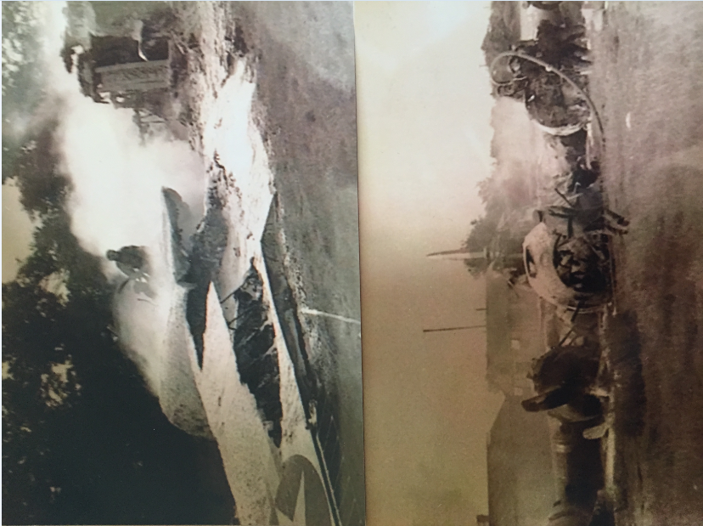
As soon as we crossed back into England, I helped several of my crewmen parachute out of the crippled plane. But my countenance was pale as we turned to land since we were too low to bail out. I held on tight as our bomber crash landed at the airbase. When we landed, our plane spun around a tree, hit a searchlight tower, and our plane caught on fire. But I was glad to be home in one piece.

Pictures taken after the crash

Note to readers: Colin’s Great Grandfather died in 1970 at an early age of 49 so not only did Colin never have the privilege of meeting him, nor did Colin’s father know his Grandfather. But Colin’s Great Grandmother passed along these heroic stories to Colin’s father who has now passed them down to his son.

